Supplementary Information
Stratford, Braun and Morrissey - Cave and rock shelter sediments of southern Africa: a review of the chronostratigraphic and palaeoenvironmental record

Supplementary Information Figures

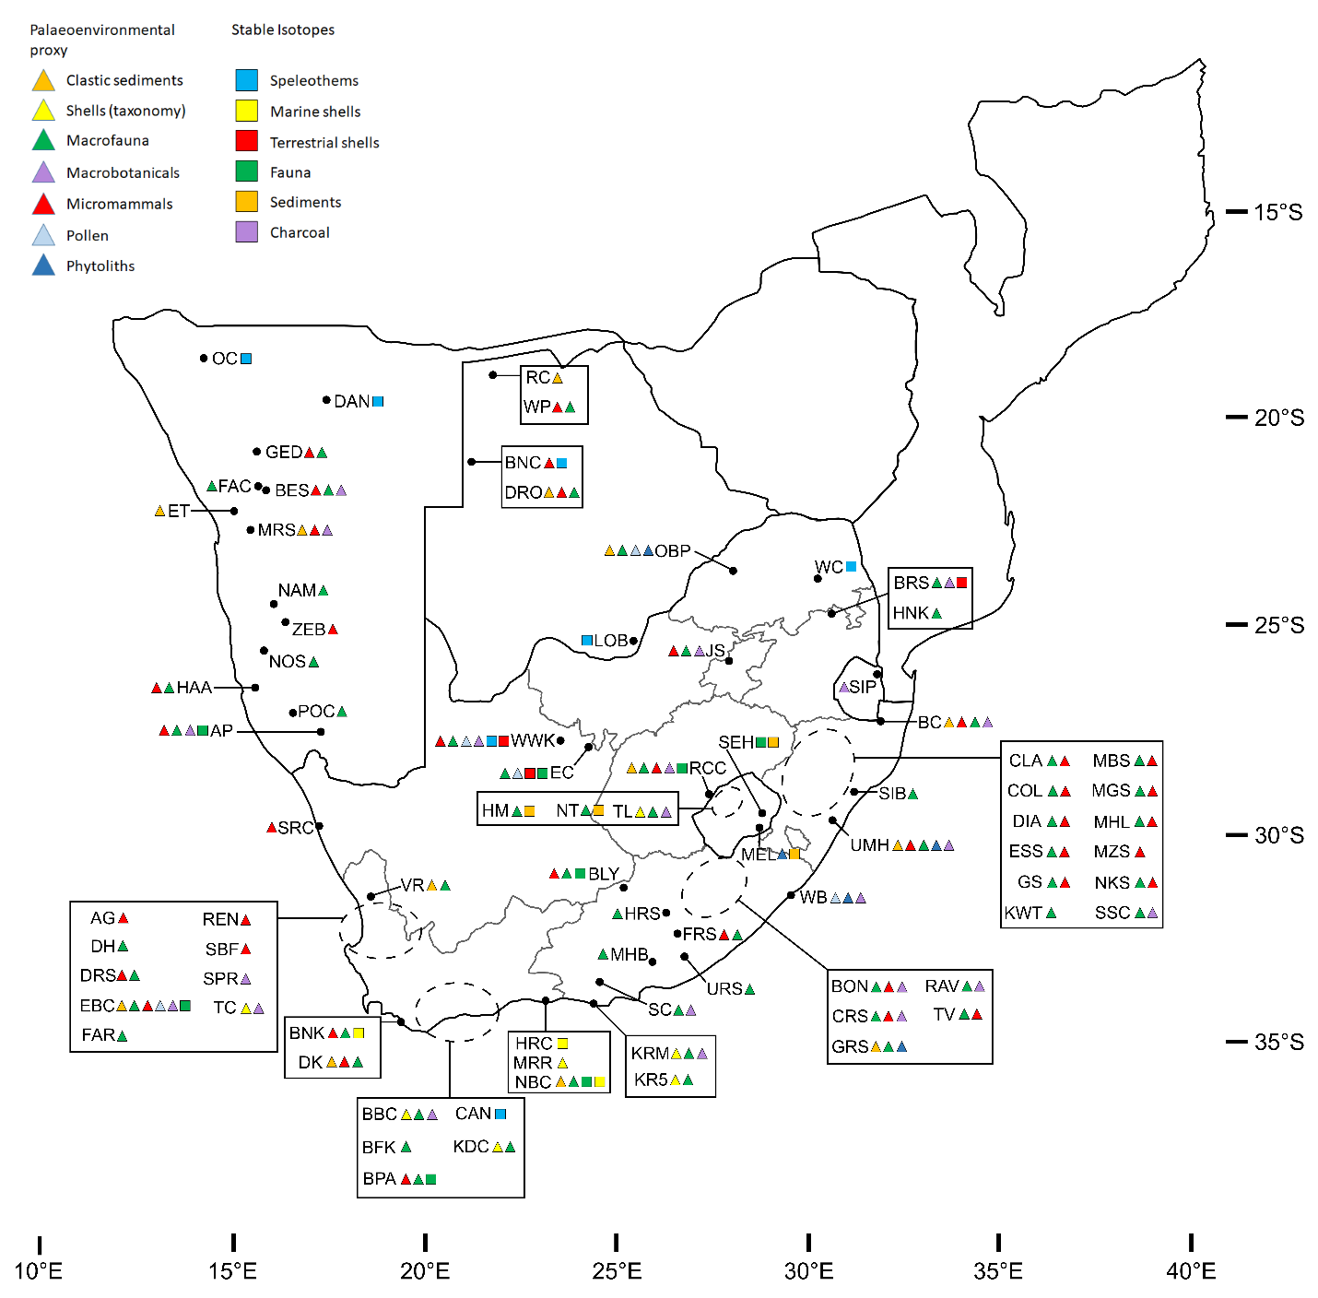

SI Figure 1. Map of southern Africa with locations of caves and rock shelter sites with published dates and palaeoenvironmental data yielded from clastic sediments and speleothems for Marine Isotope Stage 1. Sites are listed in Table 1 and discussed in text. Table 1 includes site name abbreviations.

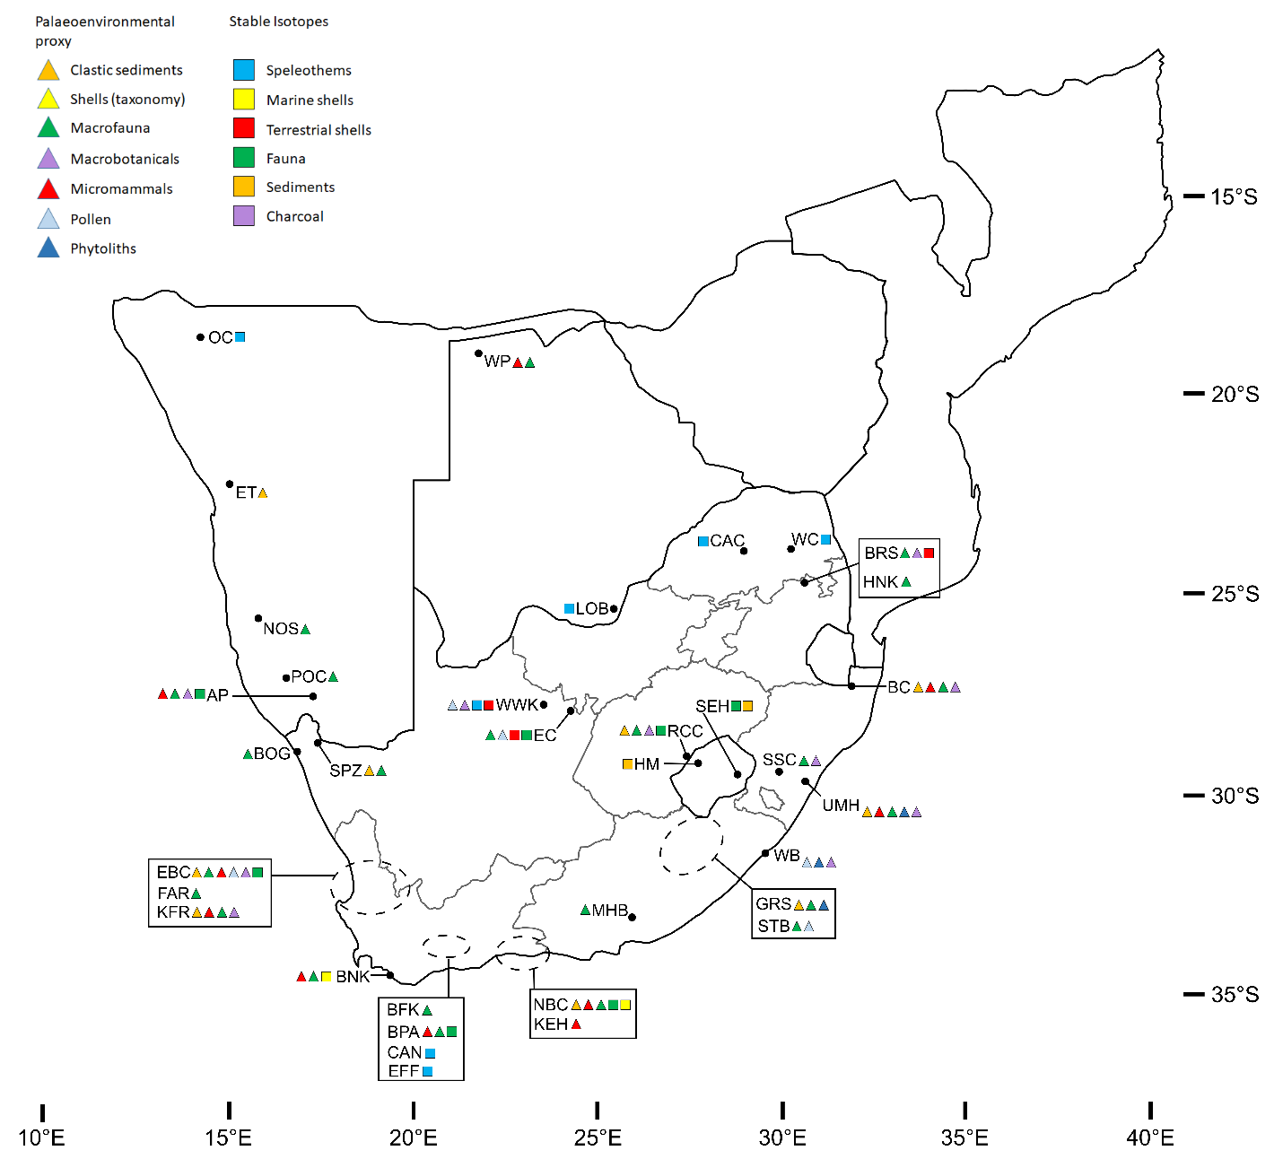
SI Figure 2. Map of southern Africa with locations of caves and rock shelter sites with published dates and palaeoenvironmental data yielded from clastic sediments and speleothems for Marine Isotope Stage 2. Sites are listed in Table 1 and discussed in text. Table 1 includes site name abbreviations.

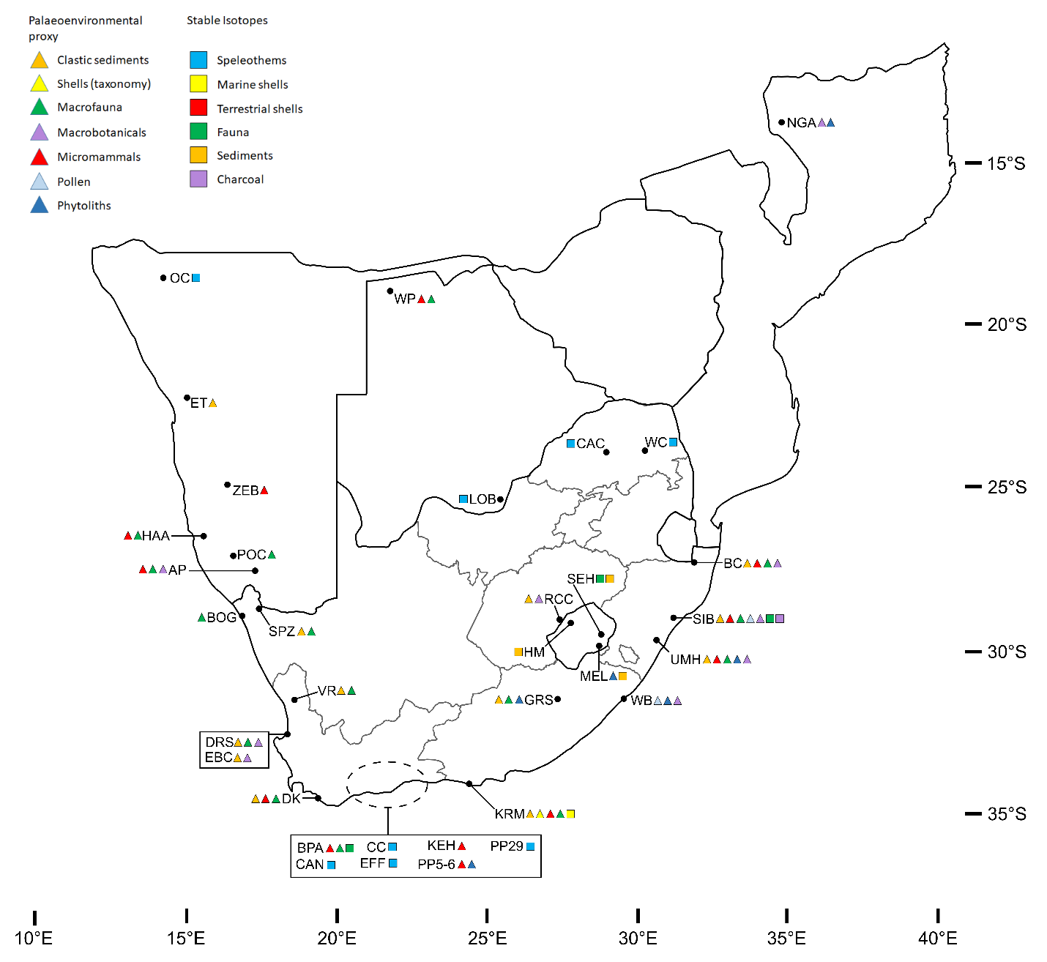
SI Figure 3. Map of southern Africa with locations of caves and rock shelter sites with published dates and palaeoenvironmental data yielded from clastic sediments and speleothems for Marine Isotope Stage 3. Sites are listed in Table 1 and discussed in text. Table 1 includes site name abbreviations.

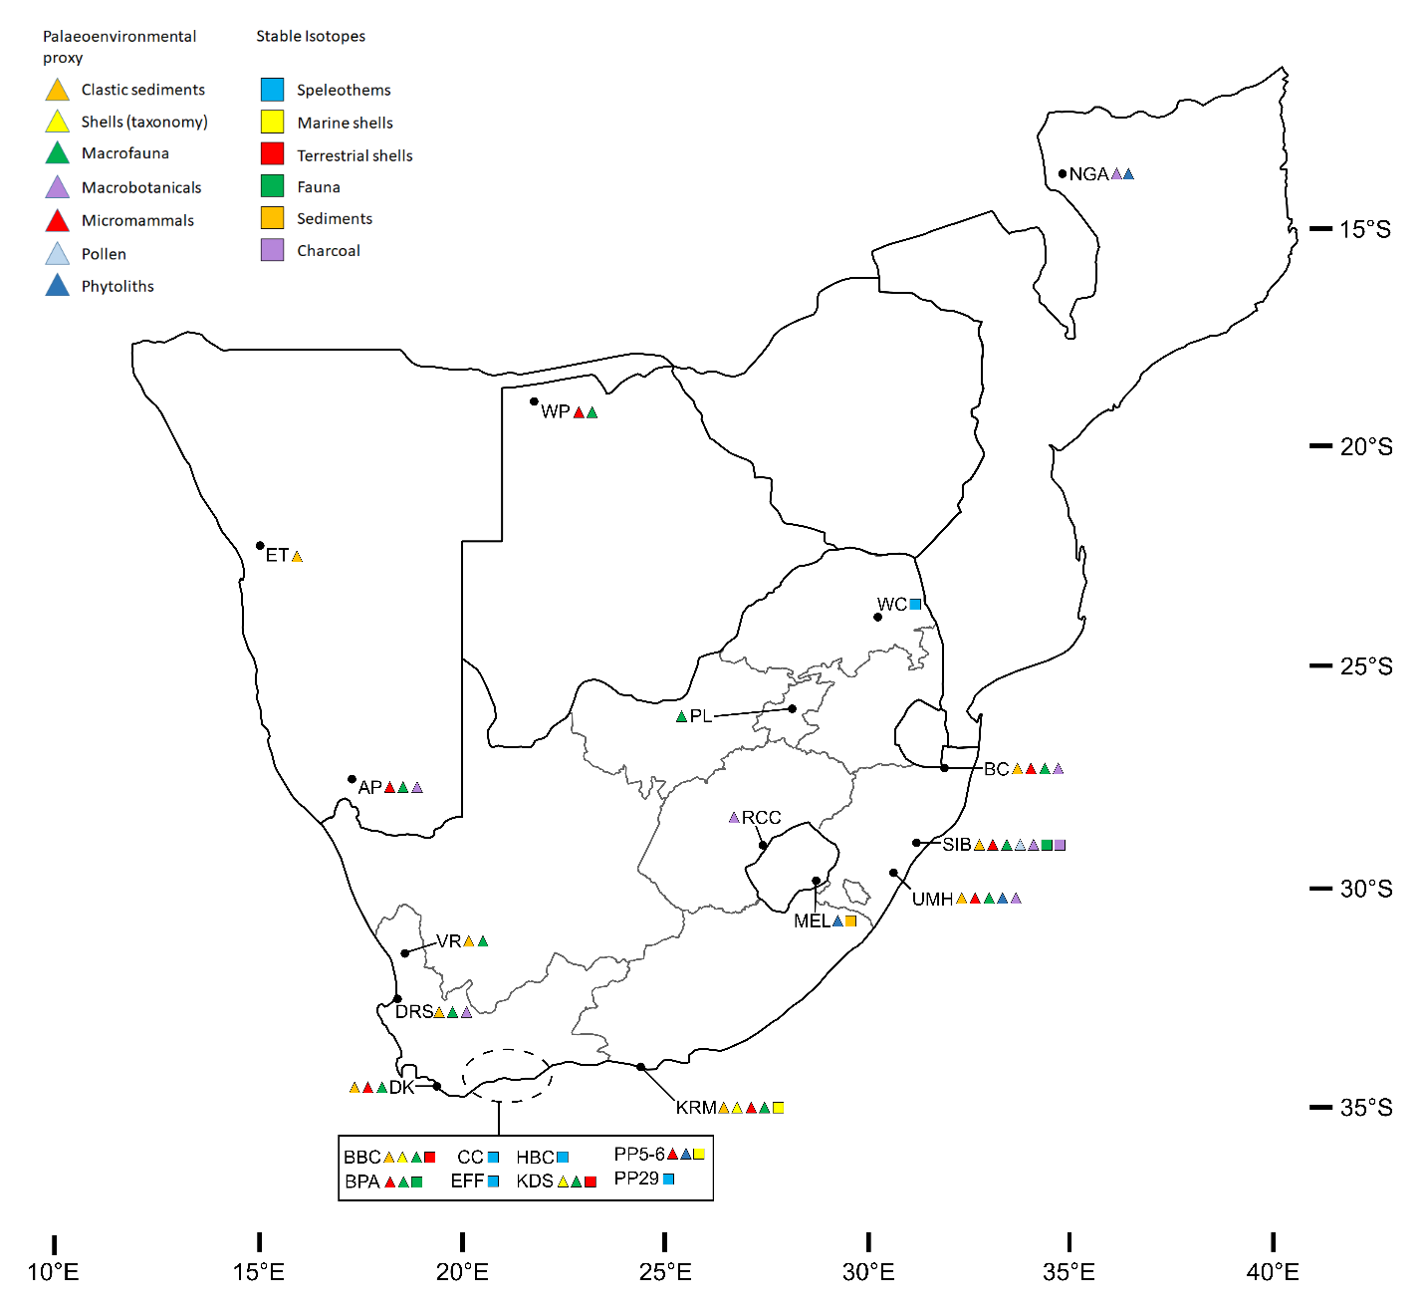
SI Figure 4. Map of southern Africa with locations of caves and rock shelter sites with published dates and palaeoenvironmental data yielded from clastic sediments and speleothems for Marine Isotope Stage 4. Sites are listed in Table 1 and discussed in text. Table 1 includes site name abbreviations.

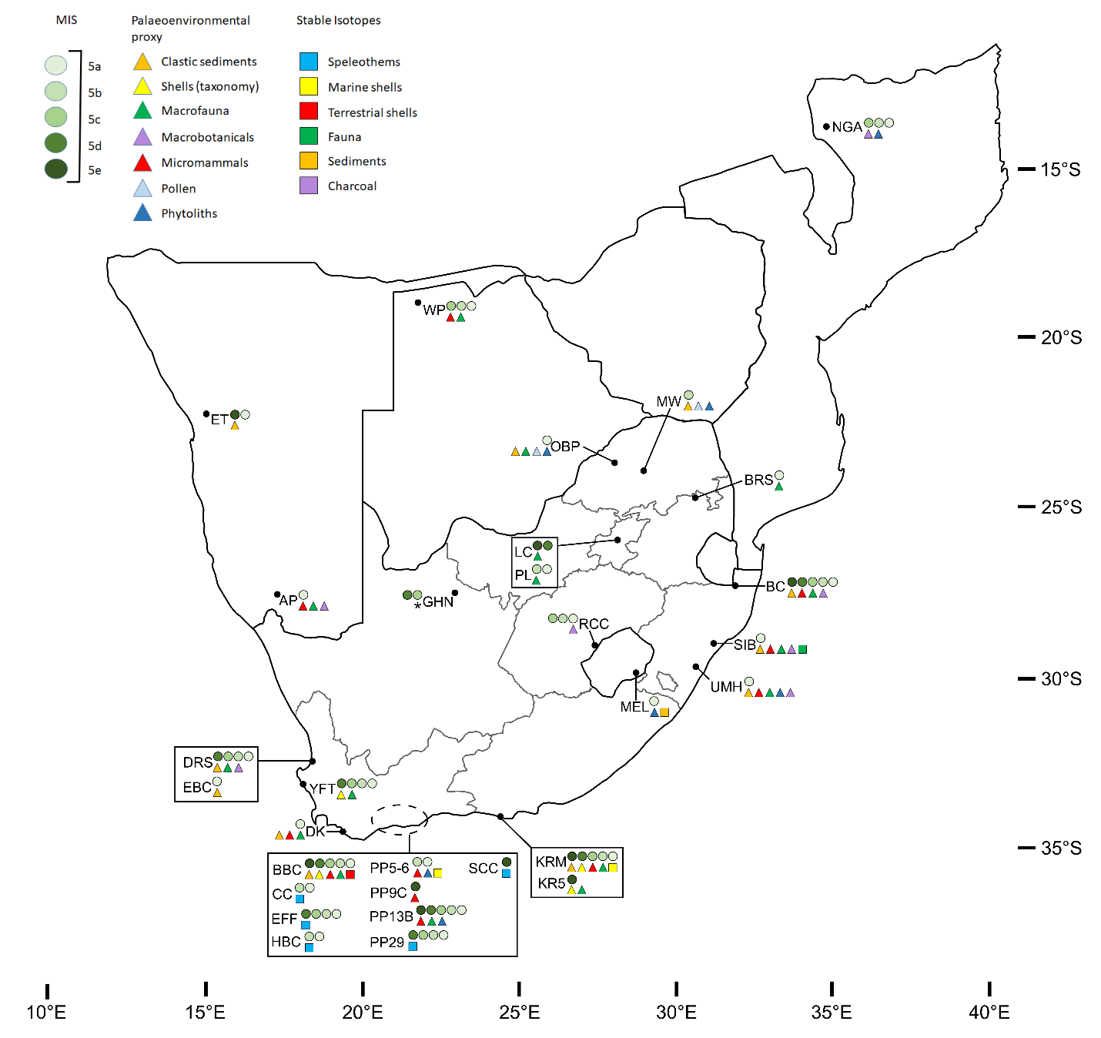
SI Figure 5. Map of southern Africa with locations of caves and rock shelter sites with published dates and palaeoenvironmental data yielded from clastic sediments and speleothems for Marine Isotope Stage 5 and substages. Sites are listed in Table 1 and discussed in text. Table 1 includes site name abbreviations. The * associated with GHN represents the use of tuff deposit growth as a palaeoenvironmental proxy.

SI Figure 6. Map of southern Africa with locations of caves and rock shelter sites with published dates and palaeoenvironmental data yielded from clastic sediments and speleothems for Marine Isotope Stage 6. Sites are listed in Table 1 and discussed in text. Table 1 includes site name abbreviations.

Supplementary Information Table

SI Table 1. Lithologies associated with the geological groupings in Figure, listed alphabetically for each grouping. These are sourced primarily from Johnson, et al. 2008, Schlüter, 2008 and McCourt, 2016 (with a significant contribution by Hielke Jelsma to the latter source). Additional sources are listed where appropriate.

Map label | Lithologies | Additional references
Recent to Neogene surficial deposits | Aeolian sand, alluvium, calcrete, colluvium, conglomerate, gravel, limestone, sandstone, silcrete
Karoo Supergroup igneous | Basalt, basaltic lava, dolerite, gabbro, granophyre, rhyolite, syenite, volcanic breccia
Karoo Supergroup sedimentary | Diamictite, mudstone, sandstone, shale
Cape Supergroup and Natal Group | Mudstone, quartzite, quartzitic sandstone, sandstone, shale
Nama Group | Arenite, dolomite, limestone, sandstone, shale
Cretaceous – Upper Jurassic sedimentary | Sandstone | Hartzer et al., 2008
Cape Granite Suite and Malmesbury Group *Includes Cango Caves Group | Arenite, conglomerate, diorite, gabbro, granite, limestone, mudrock, phyllite, quartzite, sandstone, schist
Damara Group granite | Granite
Damara Group sedimentary | Dolomite, chert, limestone, phyllite, sandstone | Clifford, 2008
Various Neoproterozoic granites, granulites, migmatites | Gneiss, granite-gneiss, leptite, metasediments, migmatite, monzonite, pyroxenite, syenite | Pinna et al., 1993
Various Neoproterozoic metamorphic and sedimentary | Amphibolite, conglomerate, dolomite, limestone, orthoquartzite, paragneiss, quartzite, sandstone, shale
Chiure Group  *Also called a supergroup in some sources | Anorthistic gabbro, gneiss, marble, metasediments, metavolcanics, myolite, quartzite, schist | Pinna et al., 1993
Various Neo-meso-proterozoic igneous and metamorphic | Arkosic arenite, basaltic lavas and pyroclastics, conglomerate, dolomite,  felsic volcanic and volcaniclastic rocks, mudstone, quartz arenite, slate | Master et al., 2010
Namaqua-Natal Belt | Amphibolite, conglomerate, gabbro, gneiss, granitoids, marble, nepheline syenite, norite, porphyritic granite, pyroclastic rocks, pyroxenite, quartzite, sandstone, schist, serpentinite, syenite, volcanic rocks
Sinclair Group and Rehoboth Sequence | Andesite, basalt, conglomerate, felsic and mafic lavas, gabbro, granite, metavolcanics, sandstone, shale, syenite, tuff | Cornell et al., 2020
Umkondo Group | Basalt, claystone, limestone, quartzite, shale, siltstone | Hartzer et al., 2008
Palaeoproterozoic metamorphics and granite gneisses | Granite gneisses, metasediments, undifferentiated metamorphics
Waterberg Group | Conglomerate, mudrock, lava, sandstone
Bushveld Complex | Anorthosite, basaltic andesite, diorite, gabbro, granite, granophyre, harzburgite, norite, pyroclastic rocks, pyroxenite, rhyolite,
Transvaal Supergroup | Andesite, basaltic andesite, chert, diamictite, diorite, dolerite, dolomite,  gabbro, gneiss, granite, quartzite, shale
Ventersdorp Supergroup | Andesite, basalt, clastic sediments, dacite, porphyry, rhyolite, tuff
Various Archean igneous and metamorphic | Amphibolite, andesite, arenite, basalt, basaltic lava, chert, conglomerate, dolerite, dunite, gabbro, gneiss, granite, granodiorite, mafic lava, marble, metaquartzite, metasediments, migmatite, mudrock, norite, porphyry, pyroxenite, quartzite, rhyolite, rudite/diamictite schist, serpentinite, shale, syenite, tuff, ultrabasic rocks, ultramafic rocks, volcanic rocks

Figure 6 assembly and sources
The simplified geological map is based largely on Schlüter’s (2008) individual geological overview maps of Botswana, Eswatini, Lesotho, Mozambique, Namibia, South Africa and Zimbabwe, and McCourt’s (2016; compiled by Hielke Jelsma) simplified geological map of southern Africa, which excluded Mozambique. Simplified geological maps of South Africa (Johnson et al., 2008) and Mozambique (Hartzer et al., 2008) were used, along with publications on different aspects of the geology of Mozambique (Pinna et al., 1993), Namibia (Clifford, 2008; Cornell et al., 2020) and Zimbabwe (Master et al., 2010) to supplement the primary sources’ descriptions of associated lithologies. The simplification of geological maps unavoidably leads to a loss of information, and this is especially pronounced when producing a map at sub-continental scale. This map is more simplified than the source maps and thus, while it provides a rough guide to the lithologies with which each of the cave and rock shelter sites are associated and helps to illustrate broad patterns relating to the distribution of published sites (including the influence of geology and the impacts of geographical bias in research), it should be interpreted with care. Further work is needed to develop a more detailed and nuanced understanding of the relationships between site distribution, geology and geomorphology.

Supplementary Information References
Clifford, T.N., 2008. The geology of the Neoproterozoic Swakop-Otavi transition zone in the Outjo District, northern Damara Orogen, Namibia. South African Journal of Geology 111, 117–140.
Cornell, D.H., Harris, M., Mapani, B.S., Malobela, T., Frei, D., Kristoffersen, M., Lehman Francko, K. and Hanson, R., 2020. Dating of Guperas Formation rhyolites changes the stratigraphy of the Mesoproterozoic Sinclair Supergroup of Namibia. South African Journal of Geology 123, 633–648.

Hartzer, F.J., Manhiça, V.J., Marques, J.M., Grantham, G., Cune, G.R., Feitio, P. and Daudi, E.X., 2008. Carta Geológica de Moçambique, Escala 1:1.000.000. Direcção Nacional de Geologia, Ministério dos Recursos Minerais, Maputo.

Johnson, M., Wolmarans, L. and Thomas, C., 2008. Simplified Geological Map of the Republic of South Africa and Kingdoms of Lesotho and Swaziland. Council for Geoscience, Pretoria.

Master, S., Bekker, A. and Hofmann, A., 2010. A review of the stratigraphy and geological setting of the Palaeoproterozoic Magondi Supergroup, Zimbabwe–Type locality for the Lomagundi carbon isotope excursion. Precambrian Research 182, 254–273.

McCourt, S., 2016. A brief geological history of southern Africa. In: J. Knight, and S.W. Grab (Editors), Quaternary Environmental Change in Southern Africa: Physical and Human Dimensions. Cambridge University Press, Cambridge, 18–29.

Pinna, P., Jourde, G., Calvez, J.Y., Mroz, J.M. and Marques, J.M., 1993. The Mozambique Belt in northern Mozambique: Neoproterozoic (1100–850 Ma) crustal growth and tectogenesis, and superimposed Pan-African (800–550 Ma) tectonism. Precambrian Research 62, 1–59.

Schlüter, T., 2008. Geological atlas of Africa. Springer-Verlag, Berlin. 307pp

