ESM 10: FA concentrations of soil and Pt and Pd concentrations of the FA fraction of series 2. (a) FA concentrations and (b) Pt and Pd concentrations of extracted FA treated with the aqua regia digestion method. (Pd*: samples with no calculated isotope ratio of Pd matching the natural isotope ratio; *a and *b: samples in trench 2 were taken at two different spots along the trench due to different characteristics of the soil profile.)
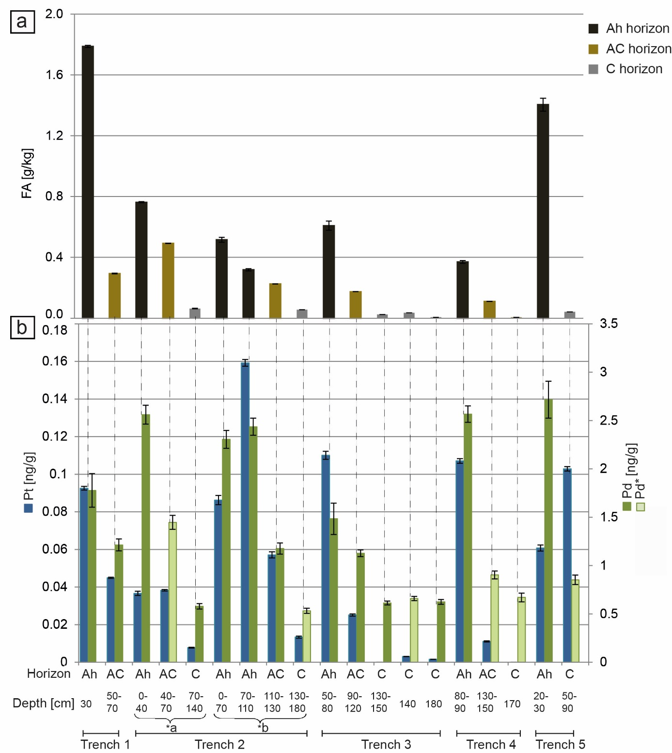
FA [mg/kg]

